Bellevue University
DSC550-T301 Data Mining (2255-1)
Linh Huynh

TERM PROJECT – FINAL

INTRODUCTION
Employee attrition, or turnover, is a serious challenge many organizations face. It can lead to significant costs in terms of recruitment, training, and lost productivity. This project addresses the problem of predicting employee attrition using data mining techniques, with the goal of identifying which employees are most at risk of leaving and why.
Solving this problem is important because early identification of at-risk employees allows HR departments to take proactive steps to improve employee satisfaction, engagement, and retention. Reducing turnover not only saves money but also helps maintain team stability and protect valuable institutional knowledge. Understanding the reasons behind attrition can lead to better workplace policies, more effective management strategies, and a healthier work environment.
To gain stakeholder buy-in, I would explain that this project has the potential to significantly reduce turnover costs and improve organizational performance. By using data-driven insights, the company can make informed decisions about how to support and retain its workforce. Predictive modeling will give HR teams a powerful tool to intervene early and personalize retention strategies, which is especially important in competitive industries like tech.
The data for this project comes from the IBM HR Analytics Employee Attrition & Performance dataset, available on Kaggle (https://www.kaggle.com/datasets/pavansubhasht/ibm-hr-analytics-attrition-dataset). This dataset includes employee details such as job satisfaction, salary, tenure, and performance scores, and includes a target column that indicates whether an employee left the company. This makes it ideal for building a predictive model to explore the patterns behind employee attrition.

DATA PREPARATION
During data preparation, the dataset was found to have 1,407 rows and 35 columns, with no missing values or duplicate rows. To prepare the data properly for modeling, it is important to encode the categorical variables using one-hot encoding. I also drop features that don’t help with prediction: ‘EmployeeCount', 'Over18', 'StandardHours', 'EmployeeNumber'.
To handle the class imbalance in the dataset, SMOTE was used to generate synthetic examples of the minority class. This helped create a more balanced training set so the models could better learn to predict employee attrition. SMOTE was only applied to the training data to avoid data leakage.

EDA - EXPLORATORY DATA ANALYSIS
For this project, the IBM HR Analytics Employee Attrition & Performance dataset was used. The exploratory data analysis showed that most employees stayed at the company, with only about 16% leaving. Several visualizations were created to explore possible patterns.

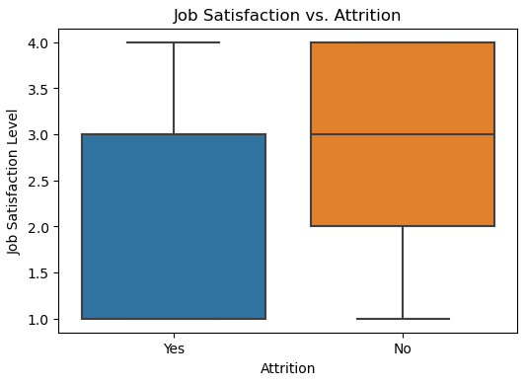
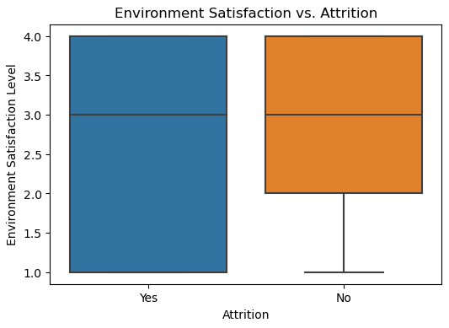
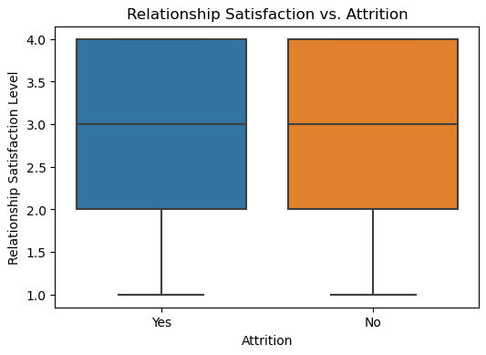

- Job Satisfaction vs. Attrition: Employees who left the company had a lower job satisfaction on average. Their scores are more spread out and lower compared to those who stayed.
- Environment Satisfaction vs. Attrition: Similar to job satisfaction, employees who left also had lower environment satisfaction. The range of scores is wider for those who left, and their median is lower.
- Relationship Satisfaction vs. Attrition: In this chart, both groups (left and stayed) look very similar. Their satisfaction levels are nearly the same, which means relationship satisfaction might not affect attrition as much as the other two.
Employees who are not happy with their job or work environment are more likely to leave the company. But their relationship satisfaction does not show a big difference. So, job satisfaction and environment satisfaction are more important reasons for why people leave. Managers should focus on improving these areas to keep employees.

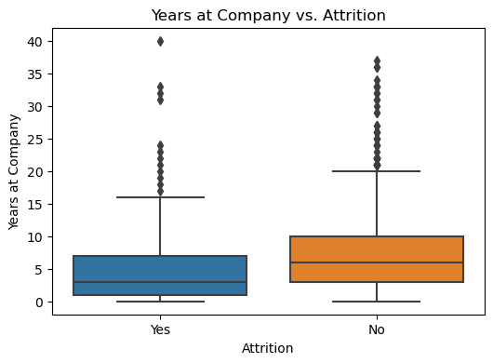
The boxplot shows that employees who leave the company usually have fewer years at the company compared to those who stay. Most employees who left had worked for about 3 to 4 years, while those who stayed had a median of around 7 to 8 years. This suggests that employees are more likely to leave during the early years of their employment. There are also more long-term employees in the group that stayed. This means that ‘YearsAtCompany’ is an important factor in predicting attrition, and HR teams may want to focus on keeping newer employees engaged to reduce turnover.
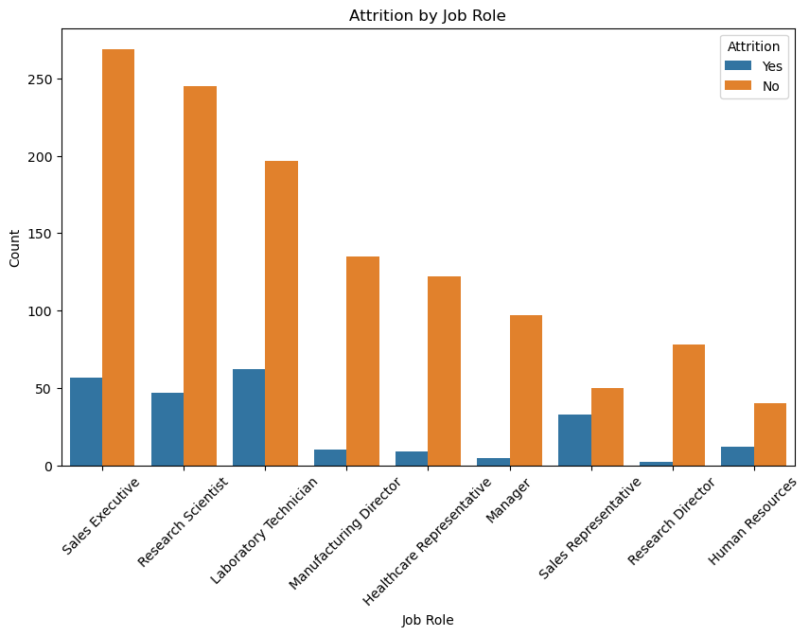
The chart shows that attrition levels vary by job role. Sales Executives, Laboratory Technicians, and Research Scientists have the highest number of employees who left the company. In contrast, job roles like Healthcare Representative, Research Director, and Manager have fewer employees leaving. Although all roles have more employees who stayed, some roles clearly show higher attrition, especially in sales and lab positions. This suggests that job type can influence employee turnover
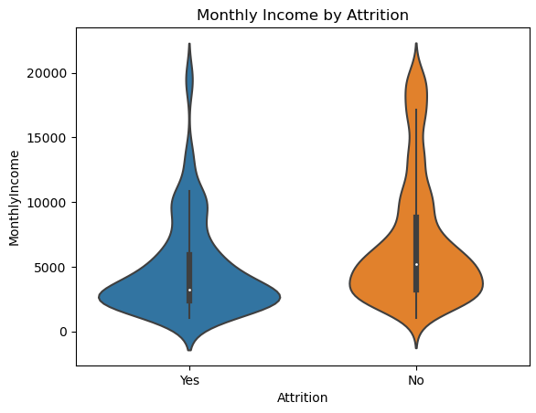
The violin plot shows the distribution of monthly income for employees who stayed versus those who left. Employees who left the company generally have lower monthly income compared to those who stayed. Most of the employees who left earn between $2,000 and $5,000, while employees who stayed show a wider spread and include more high-income earners above $10,000. Although both groups have similar ranges, the distribution for the "No" group is more stretched, suggesting that higher income may be linked to lower attrition.

MODEL BUILDING AND EVALUATION
Model Training Steps:
1. Separate Features and Target
The dataset was split into features (X) and the target variable Attrition (y).
2. Split into Train and Test Sets
The data was divided into training (80%) and testing (20%) sets using stratified sampling to keep the same ratio of attrition in both sets.
3. Apply SMOTE to Balance Classes
Since attrition is imbalanced, SMOTE (Synthetic Minority Over-sampling Technique) was used on the training set to create more examples of the minority class (employees who left).
4. Scale the Data
StandardScaler was used to normalize the feature values. The scaler was fit on the training data and applied to both training and test sets to make sure features have similar ranges.
5. Train Logistic Regression Model
A logistic regression model was trained using the scaled and balanced training data. Predictions and probability scores were generated on the test set.
6. Train Random Forest Model
A random forest classifier was trained with the same training data. Predictions and probabilities were also collected for later evaluation.
7. Train XGBoost Model
A XGBoost classifier was trained with the training data. Evaluation metrics were based on its predictions and probabilities from the test set.
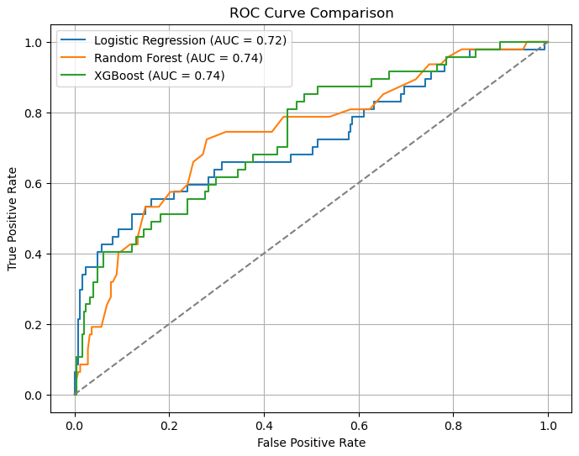

Three models were used to predict attrition: Logistic Regression, Random Forest, and XGBoost. All achieved over 80% accuracy, but their ability to detect employees who left was different.
- Logistic Regression had the best overall performance, with recall of 0.43, F1-score of 0.49, and AUC of 0.72.
- Random Forest had good accuracy but very low recall (0.19), which means it missed most of the employees who left.
- XGBoost performed better than Random Forest, with precision of 0.60 and the highest AUC (0.74), but recall was still lower than Logistic Regression at 0.32.

Overall, Logistic Regression is the best choice for this task, as it balances accuracy and recall well and does a better job at identifying employees at risk of leaving.

CONCLUSION
The analysis and model building show that it is possible to predict employee attrition using features such as job satisfaction, environment satisfaction, years at the company, job role, and monthly income. Among the three models tested, logistic regression gave the best results with a good balance between precision and recall for identifying employees who are likely to leave. However, while the model performs well, it may not be fully ready for deployment yet. More testing is needed with real-world data from the company to make sure the model works well outside of the training dataset. Also, the model could be improved with further tuning or by combining it with other methods.
My recommendation is to continue refining the model, possibly adding more relevant features such as feedback scores, promotions, or external job market data. It is also important to monitor the model regularly to ensure it remains accurate over time. One challenge is that predicting human behavior like leaving a job is complex and can be influenced by sudden personal decisions or external events, which are hard to capture in a dataset. An opportunity for future work is to turn this into a live HR tool where the model gives alerts when employees show risk of attrition, allowing the company to respond early and improve retention. By doing so, HR teams could focus on high-risk employees and take steps to keep them. This can help save costs and improve workplace stability.

